Caterpillar Job interview preparation project plan
By: Sama Al Kamachy
Date: 05/02/2026

- Project Statement:
This project involves building a Mine Fleet Sensor Data API that collects, stores, and retrieves simulated mining machine sensor data (e.g., temperature, GPS coordinates, fuel level). The system demonstrates the ability to capture real-time machine data, track fleet operations, and expose it via a RESTful API for monitoring and decision-making.

- Connection to Caterpillar & MineStar:
MineStar products provide mining customers with real-time machine tracking, monitoring, and operational insights using sensor data and control algorithms. This mini-project mirrors those capabilities on a small scale by demonstrating how sensor data can be ingested, processed, and made available for analysis, reflecting the real-world challenges and patterns of MineStar. It showcases skills relevant to both Technical Business Analysts - defining requirements, workflows, and user stories - and Software Engineers - implementing backend services, APIs, and data persistence.
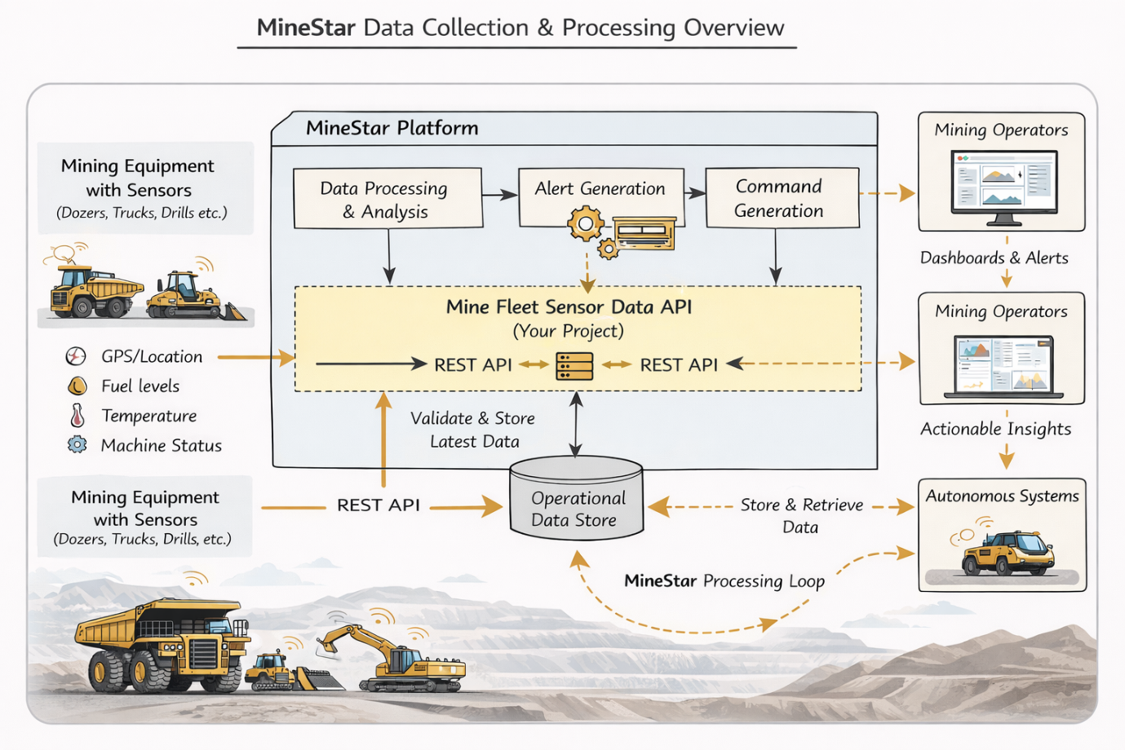
Figure 1: Minestar assumed architecture in addition to Mine Fleet Sensor Data API

- Project Plan:
Project Objectives
- Deliver a small-scale API to manage fleet sensor data.
- Demonstrate understanding of backend Java, REST APIs, and in-memory data storage.
- Create clear requirements, user stories, and acceptance criteria for each functionality.
Requirements / User Stories
- As a system, I want to receive sensor data from machines so that the latest metrics are stored.
- As a system, I want to validate sensor inputs so that invalid or missing data is rejected.
- As a user, I want to retrieve the latest sensor readings for a machine so that I can monitor fleet status.
- As a developer, I want to store data in an in-memory database so that retrieval is fast and consistent for this demo.
High-Level System Design
Components: REST API, In-memory storage (H2/Map), Data models for Machines & Sensor readings
Endpoints:
- POST /sensors → add sensor reading
- GET /sensors/{id}/latest → get latest reading
- Workflow: Sensor data submission → validation → storage → retrieval
- Testing: Test-driven-development, unit tests for endpoints, validation, and storage

- Jira Tickets:
Ticket 1 - Setup project structure
Create Maven project with proper package structure
Setup VS Code workspace and GitHub repository
Estimated time: 30 min

Ticket 2 - Write unit tests (TDD)
Test POST endpoint: valid & invalid data (UT-01, UT-02)
Test repository storage & retrieval (UT-03, UT-04, UT-05)
Test JSON response schema (UT-06)
Run all tests via Maven (mvn test)
Estimated time: 60 min

Ticket 3 - Create Temperature model
Define fields: sensorId, timestamp, temperature
Include getters, setters, and constructors
Estimated time: 30 min

Ticket 4 - Implement in-memory repository
TemperatureRepository to store latest readings keyed by sensorId
Ensure thread-safe storage using ConcurrentHashMap or equivalent
Estimated time: 60 min

Ticket 5 - Implement POST
Controller receives sensor data, maps JSON → TemperatureReading
Calls TemperatureService for validation and business logic
Returns HTTP 201 Created or HTTP 400 Bad Request for invalid input
Estimated time: 90 min

Ticket 6 - Implement TemperatureService logic
Validate required fields (sensorId, timestamp, temperature)
Check business rules (temperature threshold > 100)
Trigger alert if thresholds are exceeded
Call repository to persist reading
Estimated time: 60 min

Ticket 7 - Implement GET
Retrieve latest reading for a given sensorId
Return HTTP 200 OK with JSON or HTTP 404 Not Found if no data
Ensure consistent JSON response structure
Estimated time: 60 min

Ticket 8 - Create README
Include setup instructions, how to run tests, and project overview
Estimated time: 30 min

Ticket 9 - Final testing & demo
Execute system tests ST-01 → ST-06
Verify acceptance criteria: valid submissions, retrieval, alerts, consistent JSON, test coverage
Prepare demo (Postman collection or screenshots)
Estimated time: 60 min

- Acceptance Criteria:
- API accepts valid sensor data and rejects invalid inputs
- Latest reading for each machine can be retrieved successfully
- Unit tests cover core functionality
- Documentation is clear and demonstrates project workflow constraints & assumptions
- GitHub repository with code, tests, and documentation

- Future Improvements:
Use Jira for ticketing system.
Use database.
Add multi-threading.

